1. Download Eclipse

<http://ftp.jaist.ac.jp/pub/eclipse/technology/epp/downloads/release/kepler/SR2/eclipse-jee-kepler-SR2-win32-x86_64.zip>

1. Download pivotal server

<https://network.pivotal.io/products/pivotal-tcserver#/releases/51907/file_groups/873>

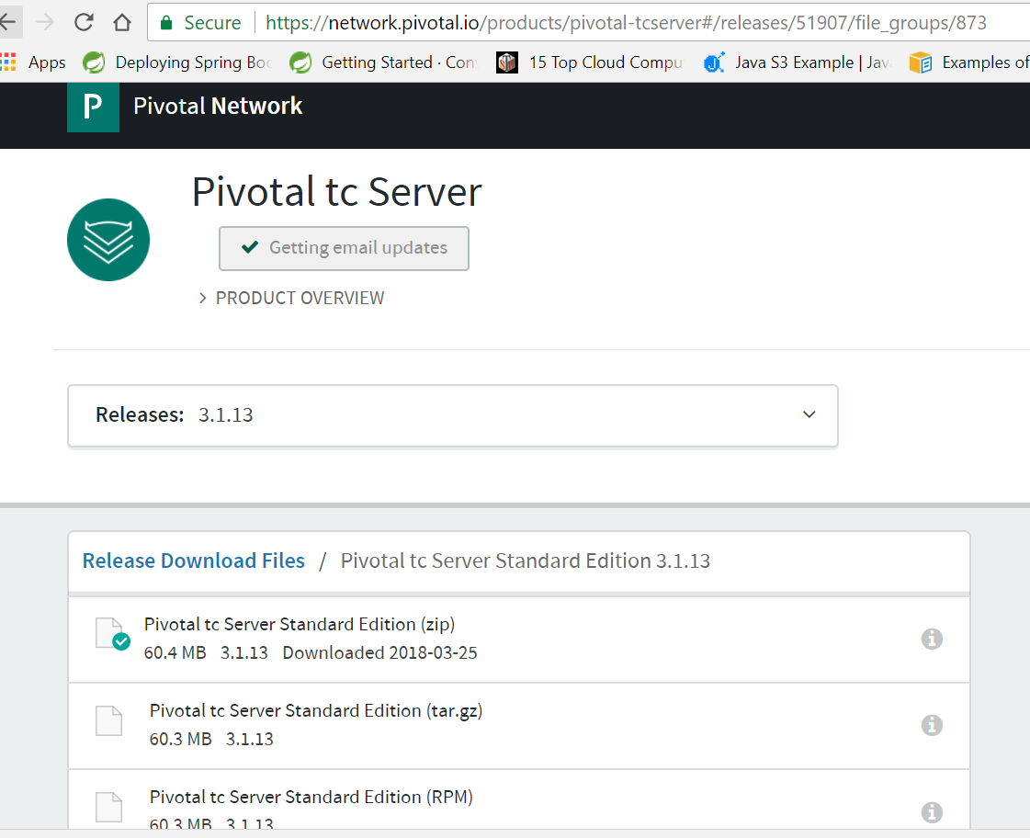

1. Extract eclipse and pivotal
2. Open eclipse
3. click on help - > market plus
4. open <http://marketplace.eclipse.org/marketplace-client-intro?mpc_install=375849> in browse

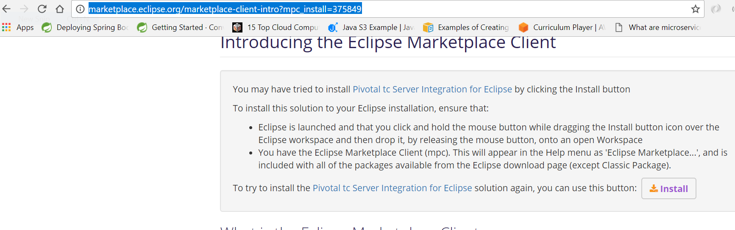

1. drag install button and drop on markenplus window

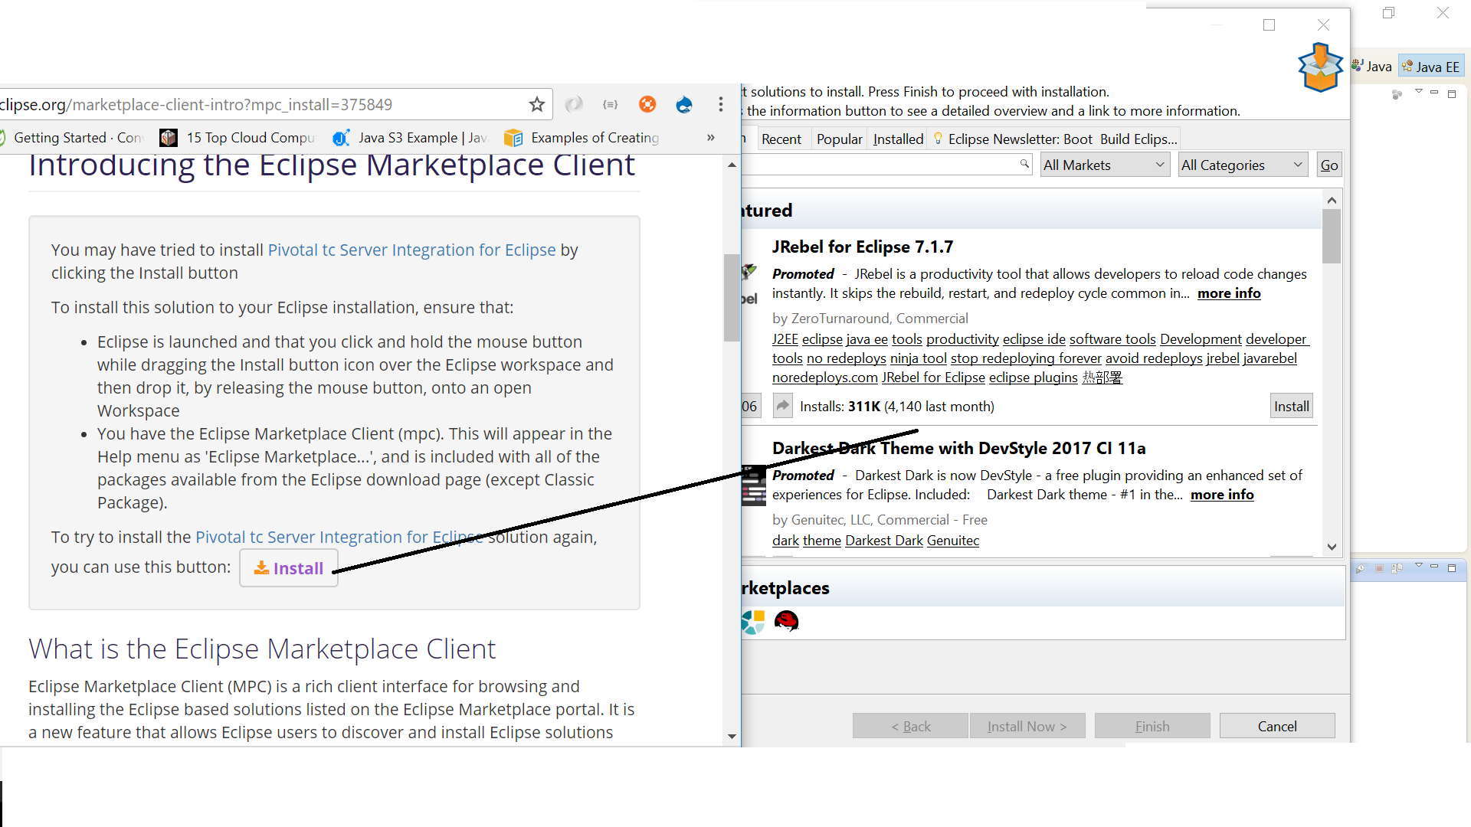

1. follow the installation steps
2. click on add new server on eclipse

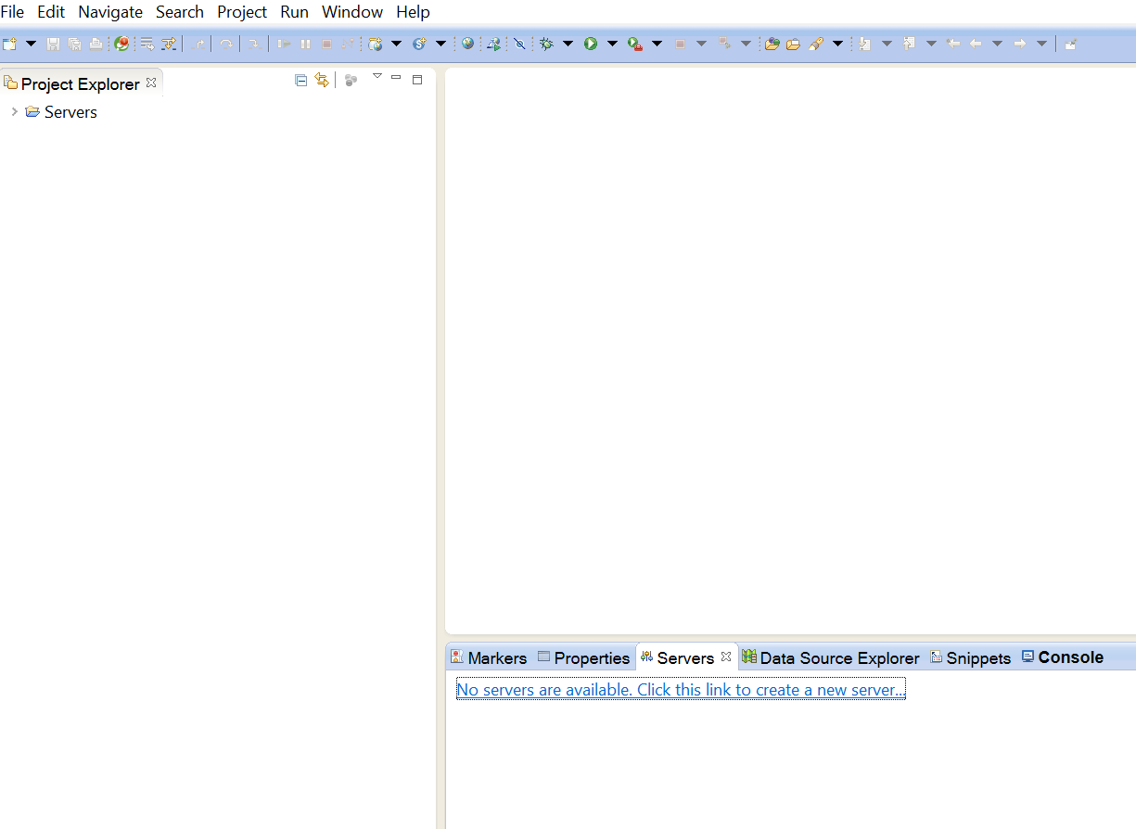

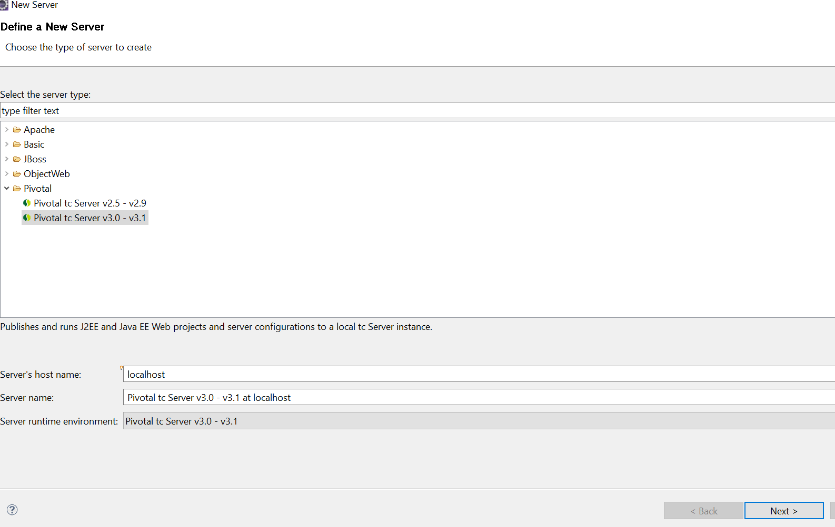

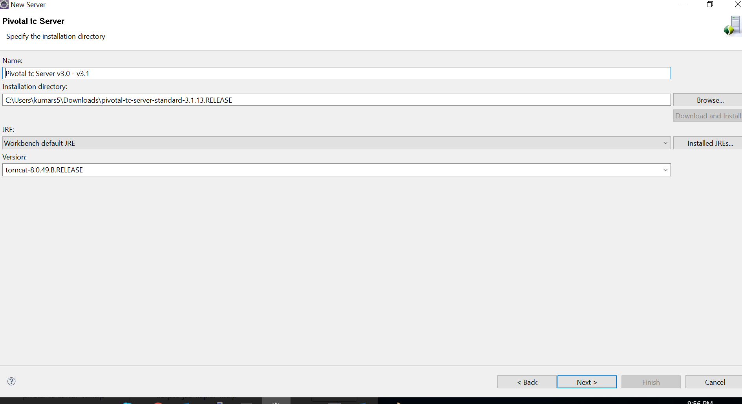click on browse select path where you extract pivotal server

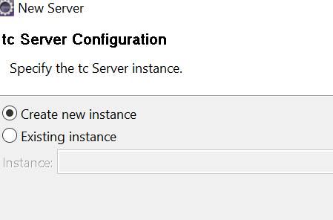

Click on new instance - > next

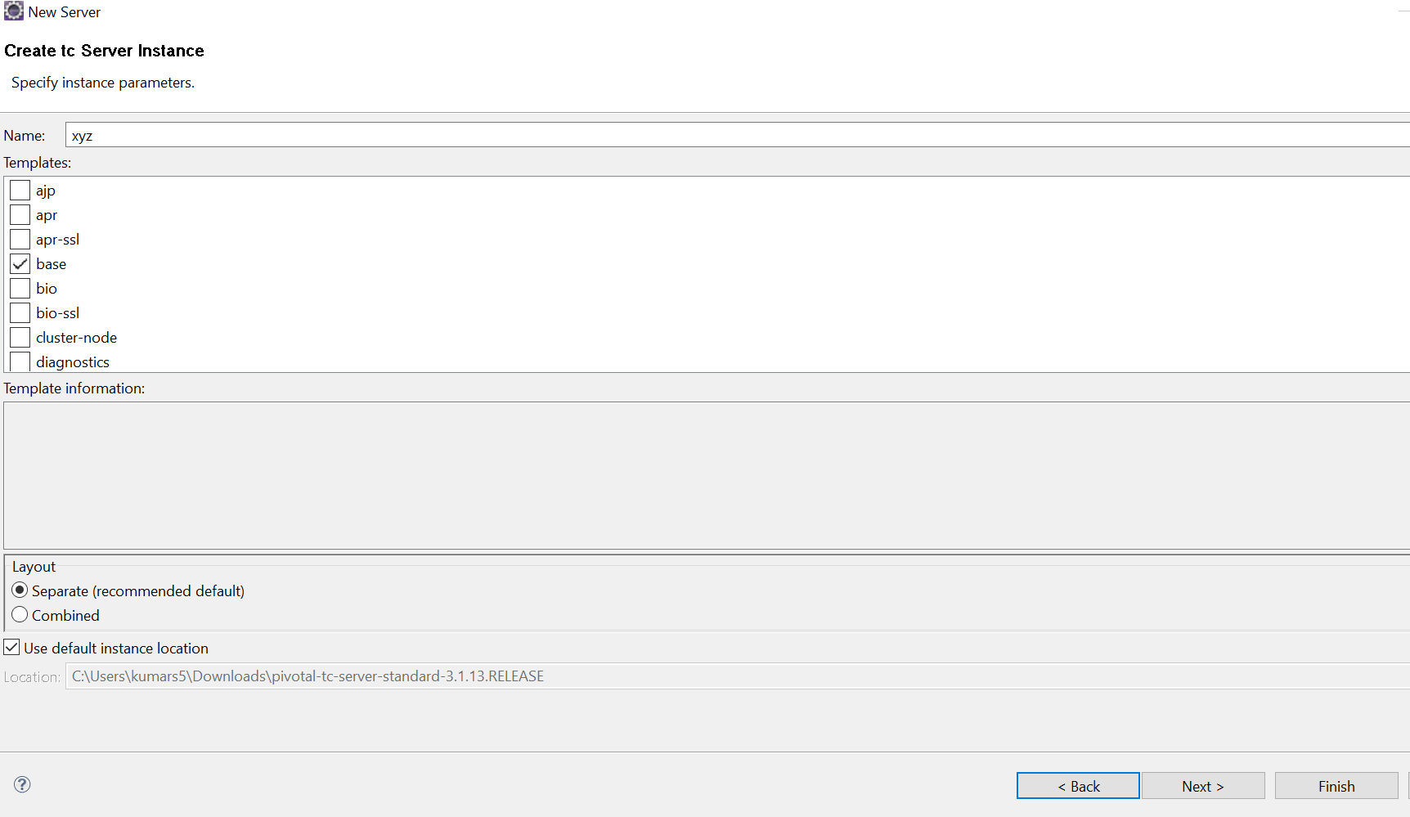

Select check box according to requirement, enter instance name in text box like “xyz”

Click on finish

Output

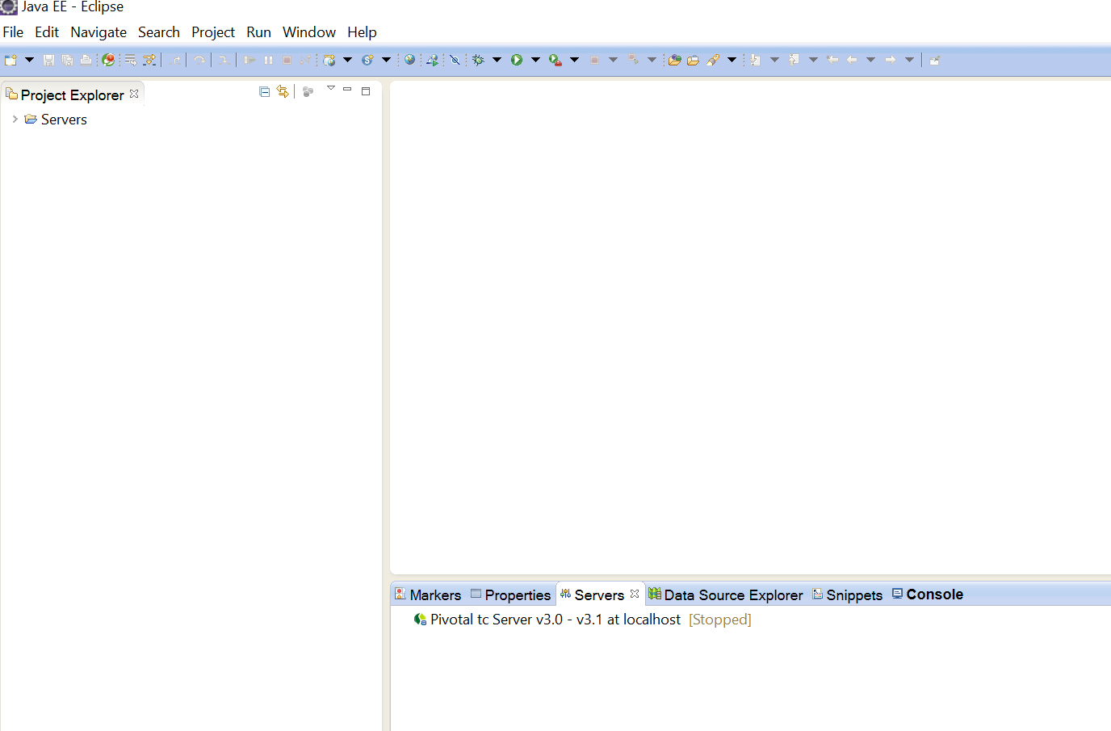

It will pivotal server

Right click on pivotal tc server - > start

